Product and Category Management System

Scenario Overview

An e-commerce company requires a database system to manage products and their categories. Each product belongs to a specific category, and the system manages details such as product name, price, stock availability, and category descriptions.

- Design Product and Category Tables
The database consists of two tables: Category and Product.

Category table

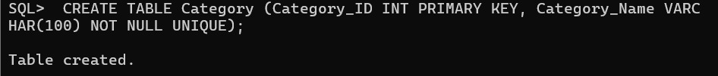

Product table

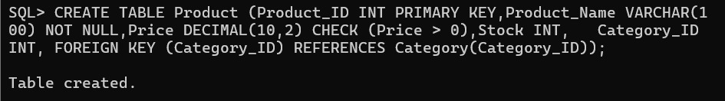

- Define Relationships and Constraints

Relationships

- Cardinality: One Category can have many Products .
- Primary Key: Category_ID in Category table; Product_ID in Product table.
- Foreign Key: Category_ID in Product table links to Category_ID in Category table.

SQL Statements for Constraints

Primary key
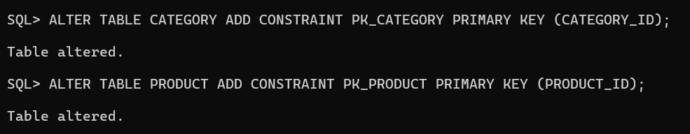

Creating relationship using forign key

Adding constraints
Not null
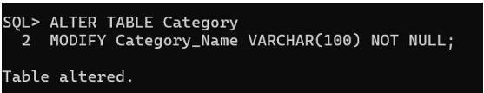
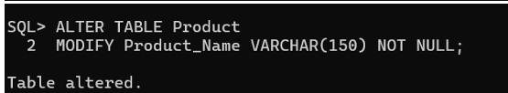

check

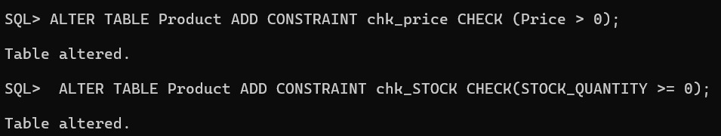

unique

3.inset values: 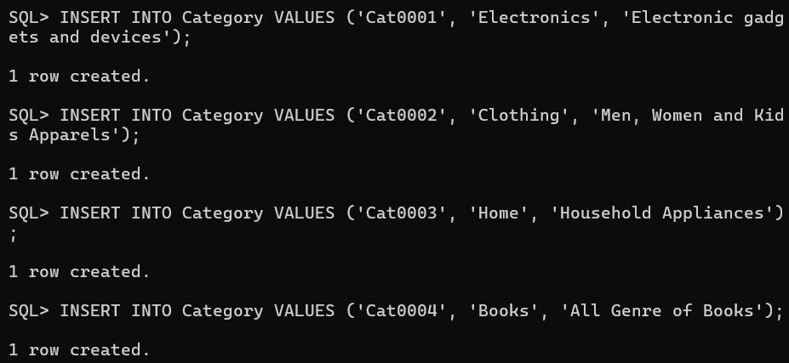
Product table

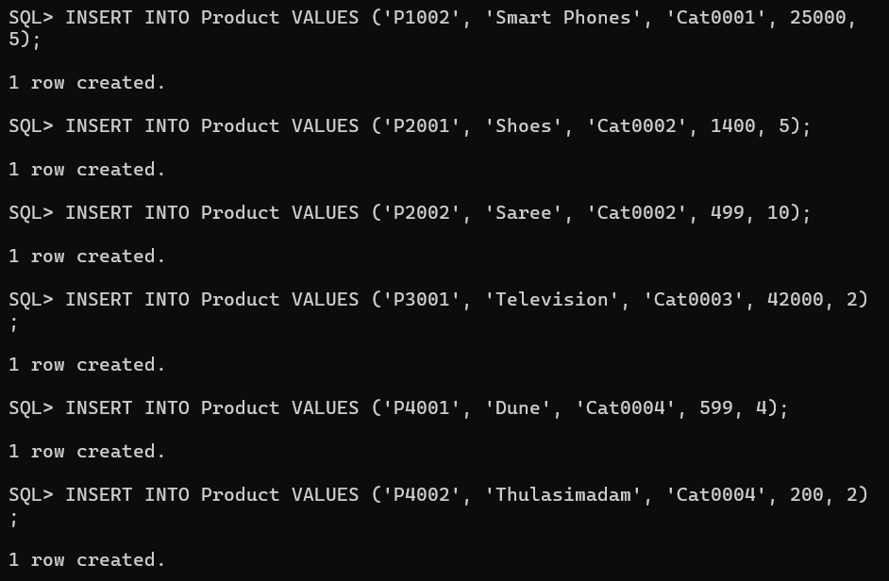

View the category table
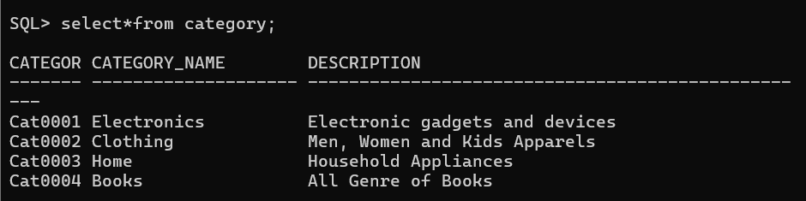
View the product table

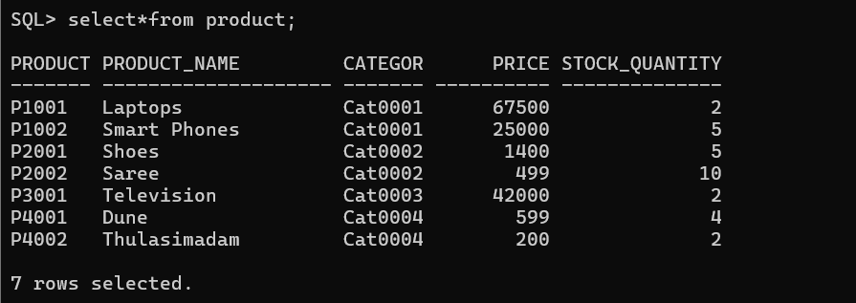
Crud operations

Insert record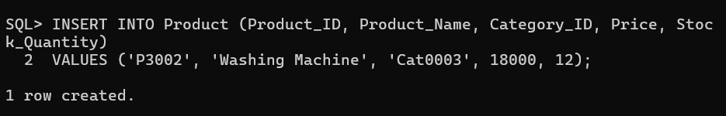

Update price:

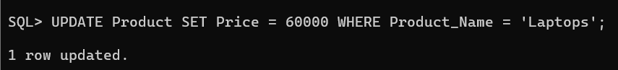
Delete a product

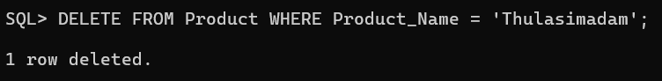

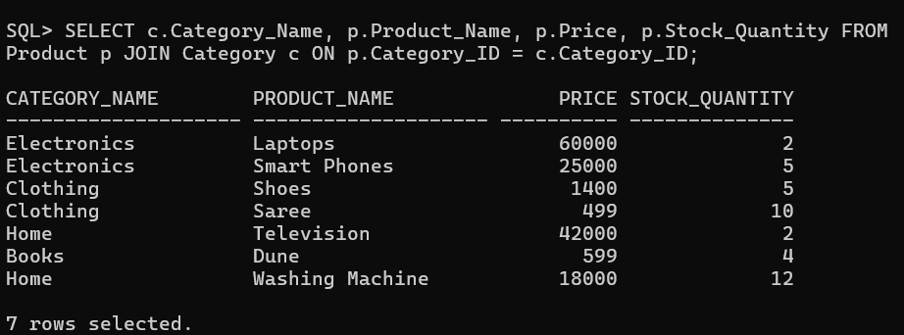

5. Generate Category-wise Product Reports Write SQL queries to:
Display all products under each category.
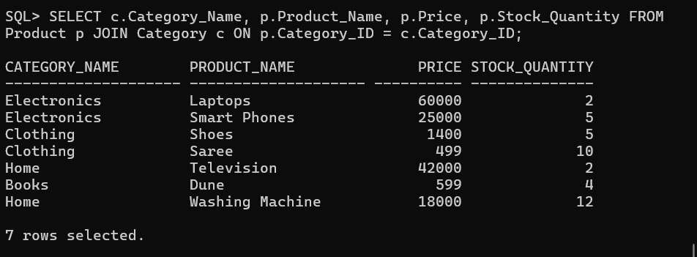

Count no.of.product in each category
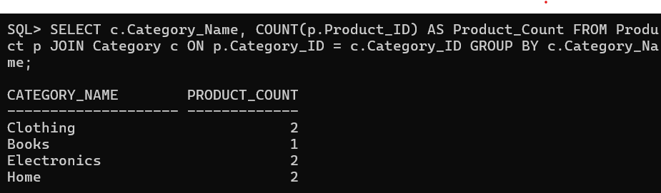

Find highest-priced product

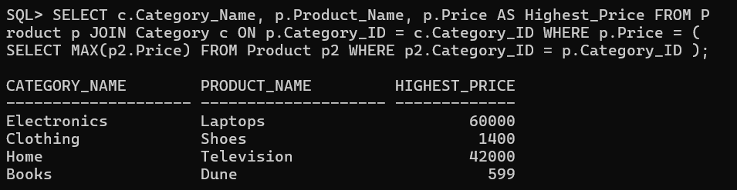

Display categories having more than 5 products.

Find average product price category-wise.

